## **Write the python program to solve 8-Puzzle problem**

## **AIM**

To implement **Breadth-First Search (BFS)** algorithm to solve the 8-Puzzle Problem and find the shortest sequence of moves from the start state to the goal state.

## **ALGORITHM**

1. Start with the **initial state** of the 8-puzzle.
2. Use a **queue (FIFO)** to explore puzzle states level by level.
3. Insert the start state into the queue and mark it as visited.
4. Repeat until the queue is empty:
5. Dequeue the front state.
6. If this state is the **goal state**, return the solution path.
7. Otherwise, generate all valid next states by moving the blank tile (0) up, down, left, or right.
8. If a new state is not visited, enqueue it and mark as visited.
9. Continue until the goal state is reached.
10. Print the sequence of states from start to goal.

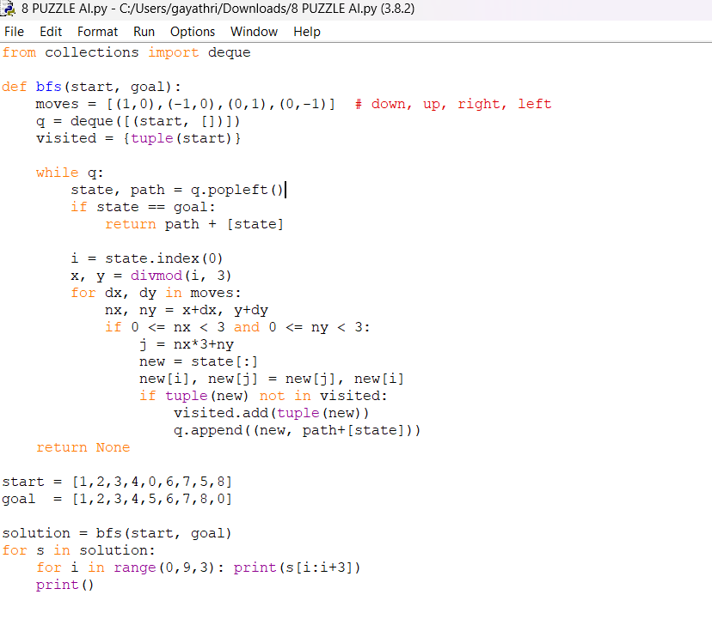

**OUTUT:**

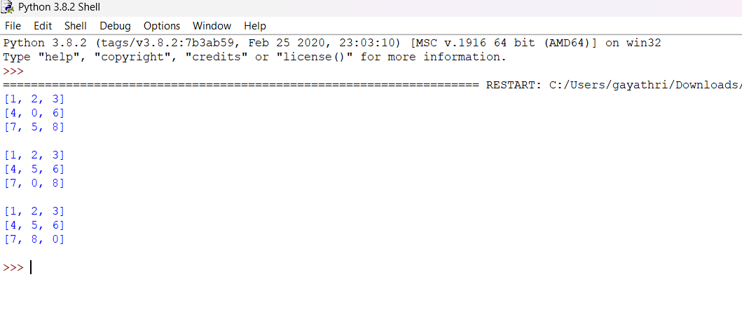

**RESULT:** The 8-Puzzle problem was successfully solved using BFS, reaching the goal state in 2 moves.